|  |
| --- |
|  |
| 新概念 3 册 |
| Lesson55 From the earth: Greetings |

Book

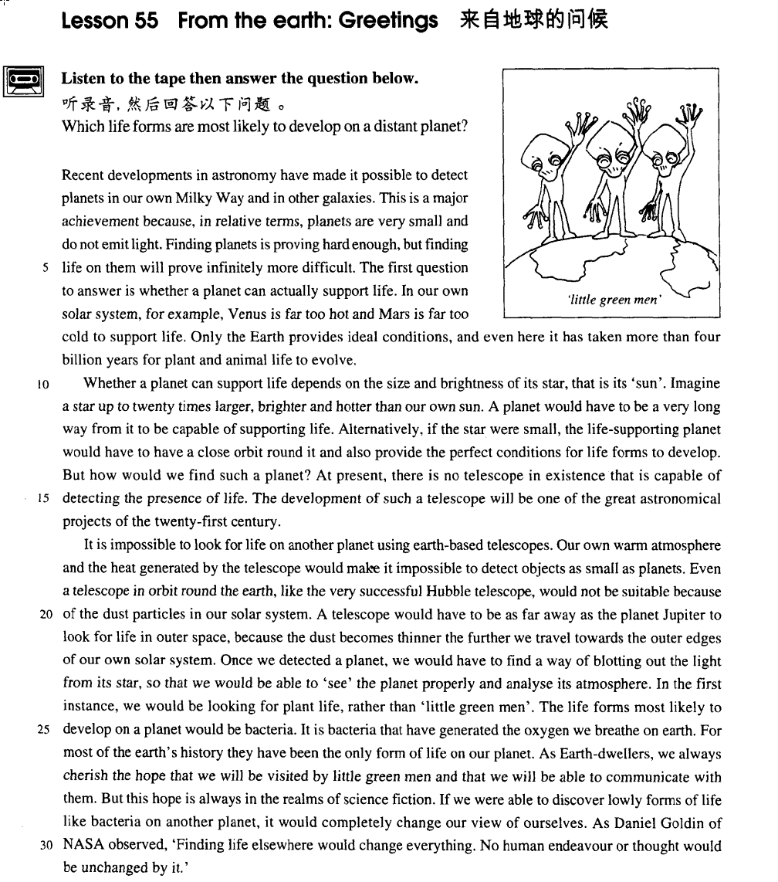

课文

Recent developments in astronomy have made it possible to detect planets in our own Milky Way and in other galaxies.

天文学方面最新发展使得我们能够在银河系和其他星系发现行星。

This is a major achievement because, in relative terms, planets are very small and do not emit light.

这是一个重要的成就，因为相对来说，行星很小，而且也不发光。

Finding planets is proving hard enough, but finding life on them will prove infinitely more difficult.

寻找行星证明相当困难，但是要在行星上发现生命会变得无比艰难。

The first question to answer is whether a planet can actually support life.

第一个需要解答的问题是一颗行星是否有能够维持生命的条件。

In our own solar system, for example, Venus is far to hot and Mars is far too cold to support life.

举例来说，在我们的太阳系里，对于生命来说，金星的温度太高，而火星的温度则太低。

Only the Earth provides ideal conditions, and even here it has taken more than four billion years for plant and animal life to evolve.

只有地球提供理想的条件，而即使在这里，植物和动物的进化也用了40亿年的时间。

Whether a planet can support life depends on the size and brightness of its star, that is its 'sun'.

一颗行星是否能够维持生命取决于它的恒星--即它的“太阳”--的大小和亮度。

Imagine a star up to 20 times larger, brighter and hotter than our own sun.

设想一下，一颗恒星比我们的太阳还要大，还要亮，还要热20倍，

A planet would have to be a very long way from it to be capable of supporting life.

那么一颗行星为了维持生命就要离开的它的恒星非常远。

Alternatively, if the star were small, the life-supporting planet would have to have a close orbit round it and also provide the perfect conditions for life forms to develop.

反之，如果恒星很小，维持生命的行星就要在离恒星很近的轨道上运行，而且要有极好的条件才能使生命得以发展，

But how would we find such a planet?

但是，我们如何才能找到这样一颗行星呢?

At present, there is no telescope in existence that is capable of detecting the presence of life.

现在，没有一台现存的望远镜可以发现生命的存在。

The development of such a telescope will be one of the great astronomical projects of the 21st century.

而开发这样一台望远镜将会是21世纪天文学的一个重要的研究课题。

It is impossible to look for life on another planet using earth-based telescopes.

使用放置在地球上的望远镜是无法观察到其他行星的生命的。

Our own warm atmosphere and the heat generated by the telescope would make it impossible to detect objects as small as planets.

地球周围温暖的大气层和望远镜散出的热量使得我们根本不可能找到比行星更小的物体。

Even a telescope in orbit round the earth, like the very successful Hubble telescope, would not be suitable because of the dust particles in our solar system.

即使是一台放置在围绕地球的轨道上的望远镜--如非常成功的哈勃望远镜--也因为太阳系中的尘埃微粒而无法胜任。

A telescope would have to be as far away as the planet Jupiter to look for life in outer space, because the dust becomes thinner the further we travel towards the outer edges of our own solar system.

望远镜要放置在木星那样遥远的行星上才有可能在外层空间搜寻生命，因为我们越是接近太阳系的边缘，尘埃就越稀薄。

Once we detected a planet, we would have to find a way of blotting out the light from its star, so that we would be able to 'see' the planet properly and analyse its atmosphere.

一旦我们找到这样一颗行星，我们就要想办法将它的恒星射过来的光线遮暗，这样我们就能彻底“看见”这颗行星，并分析它的大气层。

In the first instance, we would be looking for plant life, rather than 'little green men'.

首先我们要寻找植物，而不是那种“小绿人”。

The life forms most likely to develop on a planet would be bacteria.

行星上最容易生存下来的是细菌。

It is bacteria that have generated the oxygen we breathe on earth.

正是细菌生产出我们在地球上呼吸的氧气。

For most of the earth's history they have been the only form of life on our planet.

在地球上发展的大部分进程中，细菌是地球上唯一的生命形式。

As Earth-dwellers, we always cherish the hope that we will be visited by little green men and that we will be able to communicate with them.

作为地球上的居民，我们总存有这样的希望：小绿人来拜访我们，而我们可以和他们交流。

But this hope is always in the realms of science fiction.

但是，这种希望总是只在科幻小说中存在。

If we were able to discover lowly forms of life like bacteria on another planet, it would completely change our view of ourselves.

如果我们能够在另一颗行星上找到诸如细菌的那种低等生命，那么这个发现将彻底改变我们对我们自己的看法。

As Daniel Goldin of NASA observed, 'Finding life elsewhere would change everything. No human endeavour or thought would be unchanged by it.'

正如美国国家航空和宇宙航空局的丹尼尔.戈尔丁指出的“在其他地方发现生命会改变一切，任何人类的努力和想法都会发生变化。”

词汇讲解

* **astronomy** [ə'strɒnəmi] n. 天文学

**【词根】**

“**astr**” / “**aster**” = star

**astronomy** n. 天文学

**astronomical** adj. 天文的，天文学的；极大的

**astrology** n. 占星术；占星学；星座

**astronautics** n. 航天学；宇宙航行

**astronaut** n. 宇航员，航天员；太空旅行者

**disaster** n. 灾难，灾祸；不幸

**asterisk** n. 星号

**asteroid** n. [天] 小行星；[无脊椎] 海盘车；小游星

**【词根】【扩展】**

“stell” = star 星星

**stellar** adj. 星的；星球的；主要的；一流的

* **stellar** light
* **stellar** system

**interstellar** adj. [航][天] 星际的

* **interstellar** travel

**constellation** n. [天] 星座；星群；荟萃；兴奋丛

* a **constellation** of famous scientists and artists
* **solar** ['səʊlə(r)] adj. 太阳的
* **solar** energy 太阳能
* **solar** system 太阳穴
* **solar** radiation 太阳辐射
* **solar** calendar 阳历
* a partial（日偏食） / total（日全食） **solar** eclipse 日食

**【扩展】**

**lunar** adj. 月亮的，月球的；阴历的；银的；微亮的

* **lunar** calendar 月历
* a partial（月偏食） / total（月全食） **lunar** eclipse 月食
* **Venus** ['vi:nəs]n. 金星
* **Mercury** （水星，商贸之神墨丘利）
* **Venus** （金星，美神维纳斯）
* **Mars** （火星，战神马尔斯）
* **Jupiter** （木星，众神之王朱庇特）
* **Saturn** （土星，农神萨图恩）
* **Uranus** （天王星，天空之神乌拉诺斯）
* **Neptune** （海王星，海神尼普顿）
* **Pluto** （冥王星，冥王普路托）
* **bacteria [bæk'tɪəriə]** n. 细菌

**单数 复数**

bacteri**um** bacteri**a**

dat**um** dat**a**

medi**um** medi**a**

strat**um** strat**a**

curricul**um** curricul**a**

* **realm [relm]** n. 王国；范围，领域
* the **realm** of literature（文学） / science（科学）
* the political（政界） / military（军事领域） **realm**
* the realm of necessity 必然王国
* the realm of freedom 自由王国

**【扩展】【近义词】**

**domain** n. 领域；域名；产业；地产

* the **political** domain
* the domain of natural science

**field** / **area** / **world** / **sphere** （通俗）范围、范畴、领域

* the **field** of politics 政界
* the **world** of art 艺术界
* the **area** of education 教育领域
* the diplomatic **sphere** 外交界
* the ideological **sphere** 思想界

课文讲解

# （第一段）

# Recent developments in astronomy have made it possible to detect planets in our own Milky Way and in other galaxies.

**语法分析:**

Recent developments *in astronomy（后置定语）* have made it（形式宾语） possible to detect planets in our own Milky Way（地点状语) and in other galaxies（地点状语). （to detect… 真正宾语）

知识点（1）

**detect** v. **英文解释：**to discover or notice sth, especially sth that is not easy to see, hear, etc. 发现，觉察

* The tests are designed to **detect** the disease early.
* an instrument that can **detect** small amounts of radiation

知识点（2）

**the Milky Way** = **the Galaxy** 银河

# This is a major achievement because, in relative terms, planets are very small and do not emit light.

知识点（1）

**in relative terms 英文解释：**compared with other, similar things 相对来说

* Students have less money **in relative terms**, but spend more on books.

# Finding planets is proving hard enough, but finding life on them will prove infinitely more difficult.

知识点（1）Lesson1

**prove (to be) + adj. / n.** 被证明是……

* The search **proved difficult**, for the puma was often observed at one place in the morning and at another place 20 miles away in the evening.

知识点（2）

**infinitely** adv. **英文解释：**very much ― used esp. when comparing things （尤其与比较级连用）……得多

* Your English is **infinitely** **better** than my German.
* Travel is **infinitely** **more** comfortable now than it used to be.

**【复习】**Lesson4

**far / much / even / still / yet + 比较级** …得多

# The first question to answer is whether a planet can actually support life.

知识点（1）

**support** v. **英文解释：**to provide the right conditions, such as enough food and water, for life （提供合适的条件以）维持生命，使活下去

* The land is so poor here that it cannot **support** any crops.
* Because of pollution, this lake is now too acid to **support** fish.

# In our own solar system, for example, Venus is far to hot and Mars is far too cold to support life.

# Only the Earth provides ideal conditions, and even here it has taken more than four billion years for plant and animal life to evolve.

**语法分析:**

Only the Earth provides ideal conditions, and even here *it（形式主语）* has taken more than 4 billion years **for plant and animal life（介词for引出动词不定式的逻辑主语）** *to evolve（真正主语）*.

知识点（1）Lesson42

**it takes … (for …) to do sth.** 对某人来说做某事花了多少时间

* **It took** a few minutes **for** his eyes to adjust to the dark.
* **It** can **take** as long as eight days **to** rig up rope ladders and **to** establish supply bases before a descent can be made into a very deep cave.

# （第二段）

# Whether a planet can support life depends on the size and brightness of its star, that is its 'sun'.

**语法分析:**

Whether a planet can support life（主语从句） depends on the size and brightness of its star, that is（也就是说，引出同位语） its 'sun'.

知识点（1）

**that is (to say)**: or more exactly 也就是说，确切地说（引出同位语）

* The fare is reduced for children, **that is** anyone under 15 years old.
* One solution would be to change the shape of the screen, **that is**, to make it wider.
* Languages are taught by the direct method, **that is to say**, without using the student's own language.
* I loved him ― **that is**, I thought I did.
* I'll meet you in the city, **that is**, I will if the trains are running.
* One authority on spiders made a census of the spiders in a grass field in the south of England, and he estimated that there were more than 2,250,000 in one acre, **that is** something like 6,000,000 spiders of different kinds on a football pitch.

**【扩展】【复习】** “**i.e**”：“也就是说”

* The film is only open to adults, **i.e.** people over 18.
* The hotel is closed during low season, **i.e**. from October to March.
* The price must be more realistic, **i.e**. lower.

**【扩展】【复习】**“也就是说”

* She has worked at the bank for many years, nine **to be exact**. （后置）
* He was economical with the truth ― **in other words**, he was lying.
* It's fairly risky. Or **to put it another way**, don't try this at home.

# Imagine a star up to 20 times larger, brighter and hotter than our own sun. A planet would have to be a very long way from it to be capable of supporting life.

**语法分析:**

**祈使句：**

Imagine a star up to 20 times larger, brighter and hotter than our own sun（比较状语). （up to … 介词短语当后置定语）

知识点（1）

**语法**：**Imagine** 引导祈使句

* **Imagine** life without hot water.
* **Imagine** that you have just won a million pounds.
* **Imagine** their dismay when they found a beautifully-cooked wallet and notes turned to ash!

知识点（2）

**up to sth**. **含义1：** as much or as many as a certain amount or number but not more 多 达 ……

* The Olympic Stadium will hold **up to** 80,000 spectators.
* The temperature went **up to** 35℃. up to sth.:

**up to sth**. **含义2：** = up till （时间） **英文解释：**for the whole of a period until a certain time or date 直到……

* **Up to the time** of his death, Richard Colson was one of the most notable figures in our town.
* **Up to now,** historians have assumed that calendars came into being with the advent of agriculture, for then man was faced with a real need to understand something about the seasons.

# Alternatively, if the star were small, the life-supporting planet would have to have a close orbit round it and also provide the perfect conditions for life forms to develop.

**语法分析:**

Alternatively（副词做状语）, if the star *were（虚拟语气）* small（条件状语从句）, the life-supporting planet ***would***have to have a close orbit *round it（后置定语,修饰orbit）* and also provide the perfect conditions *for life forms to develop（后置定语修饰conditions，或可以看做目的状语；介词for引出动词不定式的逻辑主语）.*

知识点（1）

**alternatively** adv. **英文解释**used to introduce a suggestion or to mention sth. different to what has just been stated 或者

* The agency will make travel arrangements for you. **Alternatively**, you can organize your own transport.
* We could go to the Indian restaurant, or **alternatively**, we could try that new Italian place.

知识点（2）复习

life-supporting 复合形容词

语法：复合形容词简化定语从句

* the planet which supports life
* the **life-supporting** planet
* animals which eat insects
* **insect-eating** animals
* silverware which is made by hands
* **hand-made** silverware
* diseases which are related to stress
* **stress-related** diseases
* **state-owned** enterprises 国有企业
* **flower-selling** girls 卖花女孩
* **epoch-making** masterpieces 划时代的作品
* cancer-causing substances 致癌物质

知识点（3）

**语法：**并列句的省略

* Alternatively, if the star were small, the life-supporting planet **would have to** have a close orbit round it **and** (**would**) also (**have to**) provide the perfect conditions for life forms to develop.

知识点（4）

**语法：for…to do** 引出动词不定式的逻辑主语

* He opened a door and stood aside for *her* to pass.
* Her circumstances had never been good enough for ***her hopes*** to be realized.

# But how would we find such a planet?

知识点（1）复习

**语法：**虚拟语气的省略

* 课文补全：
* But how *would* we find such a planet if there *were* such a planet?

# At present, there is no telescope in existence that is capable of detecting the presence of life.

**语法分析:**

At present（介词短语做状语）, there is no telescope *in existence（介词短语当后置定语）* **that** is capable of detecting the presence of life. （**that** ...定语从句，修饰）

知识点（1）

**in existence** 存在

* The organization has been in existence for 25 years.

**【复习】**Lesson38

**come into existence** 开始存在

* Scientists have many theories about how the universe first **came into existence**.

知识点（2）Lesson54

**presence** n. **英文解释：** the existence of sb. or sth. in a particular place 存在

**one’s presence** 某人的存在

* **Her presenc**e during the crisis had a calming effect.
* We enjoy staring at them entranced as they go about their business, unaware (we hope) of **our presence**.

**the presence of …** …的存在

* Tests revealed **the presence of** poison in the blood.
* **The presence of** pollen in the atmosphere causes hay fever in some people.

**detect the presence of …** 寻找……

* a device for **detecting the presence of** submarines
* The dogs were trained to **detect the presence of** explosives.

# The development of such a telescope will be one of the great astronomical projects of the 21st century.

知识点（1）

**develop** v. **英文解释：** to design or make a new idea, product, system etc. over a period of time 开发，研制

* Scientists are **developing** new drugs to treat arthritis.

**development** n. t**英文解释：** he process of creating a new product or method 开发，研制

* His work is mainly in software **development**.
* The funds will be used for product **development**.

知识点（2）

**写作：**正规书面语中名词更正式

* **Gre范文：**
* **The resolution of** some problems of today is urgent and critical for the survival of a society.
* **Overemphasis upon** some existing problems could cause harmful effects.
* **The efforts** to solve problems of the future **is** sometimes **of paramount importance** for **the avoidance** of potentia**l** threats or even catastrophes we can anticipate.
* **举例：**
* **His acceptance of** bribes led to his arrest.
* **My arrival** coincided with **his departure.**

# （第三段）

# It is impossible to look for life on another planet using earth-based telescopes.

**语法分析:**

It（主语从句） is impossible to look for life on another planet using earth-based telescopes（非谓语动词做方式状语）. （to... 真正主语）

知识点（1）

**【词根】**

**-based** 常用语构成复合形容词的词根

**-based** **含义1：** combines with nouns referring to places to mean sth. positioned or existing mainly in the place mentioned, or operating or organized from that place 位于

* …… a **Washington-based** organization
* **land-based** missiles

**-based 含义2：**used with some names to make adjectives describing the main substance in a product主要成分为……

* **lead-based** paints
* **carbon-based** fuels
* **nitrogen-based** fertilizer
* pasta and other **wheat-based** products

# Our own warm atmosphere and the heat generated by the telescope would make it impossible to detect objects as small as planets.

**语法分析:**

Our own warm atmosphere and the heat generated by the telescope（过去分词短语做后置定语，修饰heat） *would（虚拟语气）* make it（形式宾语） impossible *to detect objects as small as planets（后置定语，修饰objects）*. （to…真正宾语）

知识点（1）

**语法：**虚拟语气的省略

* 课文补全：
* Our own warm atmosphere and the heat generated by the telescope *would* make it impossible to detect objects as small as planets if we *looked* for life on another planet using earth-based telescopes.

# Even a telescope in orbit round the earth, like the very successful Hubble telescope, would not be suitable because of the dust particles in our solar system.

**语法分析:**

Even a telescope *in orbit round the earth（后置定语，修饰orbit）*, like the very successful Hubble telescope, *would（虚拟语气）* not be suitable *because of the dust particles in our solar system*. *（原因状语从句)*

知识点（1）

**语法：**虚拟语气的省略

* 课文补全：
* Even a telescope in orbit round the earth, like the very successful Hubble telescope, *would* not be suitable because of the dust particles in our solar system if we *looked* for life using a telescope in orbit round the earth.

知识点（2）

**哈勃望远镜：**

Hubble Edwin Powell 1889-1953. American astronomer who discovered (1929) that the velocities of nebulae increase with distance

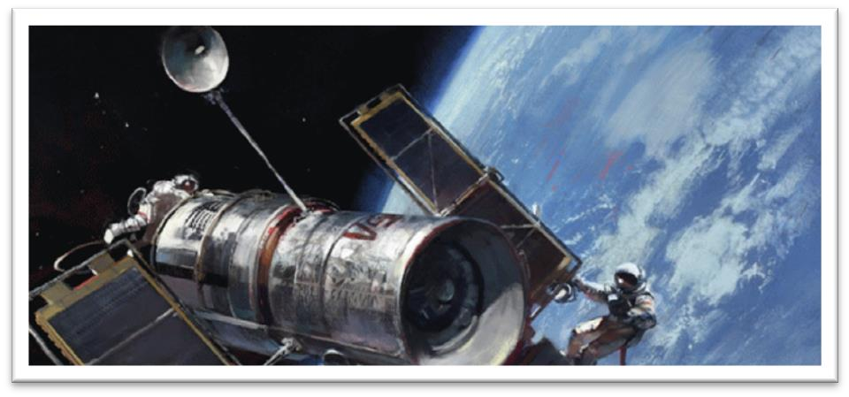

Hubble Space Telescope (HST)

The Hubble Space Telescope is a telescope in orbit around the Earth.

Its position outside the Earth's atmosphere allows it to take extremely sharp images, and since its launch in 1990, it has become one of the most important telescopes in the history of astronomy.

It has been responsible for many ground-breaking observations and has helped astronomers achieve a better understanding of many fundamental problems in astrophysics.

知识点（3）

**particle** n. **英文解释：**a very small piece of sth. 微粒

* dust **particles**
* tiny **particles** of soil
* **elementary particle** n. **英文解释：**one of the types of pieces of matter including electrons, protons, and neutrons that make up atoms 基本粒子

# A telescope would have to be as far away as the planet Jupiter to look for life in outer space, because the dust becomes thinner the further we travel towards the outer edges of our own solar system.

**语法分析:**

A telescope *would（虚拟语气）* have to be as far away as the planet Jupiter *to look for life in outer space*, because the dust becomes thinner *the further we travel towards the outer edges of our own solar system（比较状语从句)*. （because... 原因状语从句)

知识点（1）

**语法：**虚拟语气的省略

* 课文补全：
* A telescope would have to be as far away as the planet Jupiter to look for life in outer space if we *looked* for life in outer space, because the dust becomes thinner the further we travel towards the outer edges of our own solar system.

知识点（2）Lesson9、43、55

**语法**：“**越…越…**”比较

**1.两个the 分别放在句首，前半句从句，后半句是主句，从前往后翻译**

* The harder they worked(前半句从句，类似条件状语从句) the hungrier they became. （后半句是主句）
* The more he gets, the more he wants
* The harder you work, the greater progress you will（时态：主将从现） make.
* **主句倒装**
* The younger the child is （从句）, the more *is* the child’s need of sleep. （主句，倒装）
* The more democracy spreads, the stronger *become*（倒装）the forces of peace.
* **如果谓语动词是be动词，这种句型可省略:**
* The younger the child *is*, the more *is / will be* the child’s need of sleep.
* The younger the child, the more the child’s need of sleep. （be动词省略）
* The higher the standard of living, the greater the amount of paper used. （be动词省略）
* The higher the standard of living *is*, the greater *is / will be*（倒装）the amount of paper used.
* **课文写法替换：**Lesson44
* Needless to say, the bigger the risk an insurance company takes, the higher the premium you will have to pay.
* Needless to say, the bigger the risk an insurance company takes *is,* the higher *will be*（倒装）the premium you will have to pay.

**2.第一句the加比较级放在句中，第二句the加比较级放在句首，只能先翻译后半句，再翻译前半句**

* They became (the) hungrier （前半句是主句）the harder they worked.（后半句是从句）
* A telescope would have to be as far away as the planet Jupiter to look for life in outer space, because the dust becomes thinner（主句） the further we travel（从句） towards the outer edges of our own solar system.
* We are so familiar with the fact that man ages, that people have for years assumed that the process of losing vigour with time, of becoming more likely to die（主句） the older we get（从句）, was something self-evident, like the cooling of a hot kettle or the wearing-out of a pair of shoes.

# Once we detected a planet, we would have to find a way of blotting out the light from its star, so that we would be able to 'see' the planet properly and analyse its atmosphere.

**语法分析:**

Once we *detected（类似if从句的虚拟）* a planet（时间状语）, we *would（虚拟语气）* have to find a way *of blotting out the light from its star（后置定语）*, so that we *would* be able to 'see' the planet properly and analyze its atmosphere.（so that…would 目的状语从句）

知识点（1）

**way of doing sth.** 做某事的方式

* a new **way of** storing information

**way to do sth.** 做某事的方式

* What is the best **way to** clean this?

知识点（2）

**blot** n. **英文解释：**a mark or dirty spot on sth., esp. made by ink 污点，墨迹

* ink **blots**
* This is a serious **blot** on your career. （派生：污点）

**blot out 英文解释：**to cover sth. so that you can no longer see it 遮住

* Dark clouds overhead had **blotted out** the sun.

知识点（3）Lesson43

**语法：so (that) 作连词时一般来说有两种用法**：

1. 引导结果状语从句，译为“所以”，从句谓语动词中一般没有情态动词。

2. 引导目的状语从句，译为“以便”= in order that …，从句谓语动词中多出现情态动词 can, could, may, might, should, would 等。

* We paid him immediately, **so (that)** he left contented. （所以）
* We paid him immediately, **so (that)** he would leave contented. （以便）
* The pie committee decided that the best way to transport the dish would be by canal, **so**（所以） they insured it for the trip.
* In the new country he became absorbed in making a new life for the two of us, **so that** （所以）he gradually ceased to grieve.
* It had been purchased by a local authority **so that** （以便）an enormous pie **could** be baked for an annual fair.
* This time they fixed heavy metal clamps to both sides of the dish **so that** （以便）they **could** fasten the chains.

知识点（4）

**properly** adv. (BrE) **英文解释：**completely, fully, thoroughly 完全地，彻底地

* Is the chicken **properly** defrosted?
* He got **properly** beaten by the world champion.

# In the first instance, we would be looking for plant life, rather than 'little green men'.

知识点（1）

**语法：**虚拟语气的省略

* 课文补全：
* If we *looked* for life on a planet, in the first instance, we *would* be looking for plant life, rather than 'little green men'.

知识点（2）

**in the first instance** (fml.) **英文解释：**as the first part of a series of actions 首先，第一

* **In the first instance**, notify the police and then contact your insurance company.
* Anyone wishing to join the society should apply **in the first instance** to the secretary.

知识点（3）

**Little green men** （【idiom】）is a popular expression used to describe extraterrestrial life.

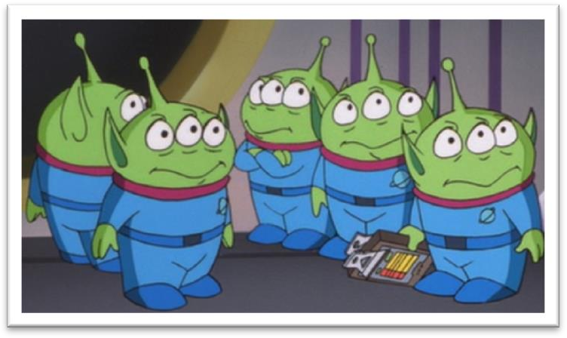

# The life forms most likely to develop on a planet would be bacteria.

**语法分析：**

The life forms most likely to develop on a planet（后置定语） *would（虚拟语气）* be bacteria.

知识点（1）

**语法：**虚拟语气的省略

* 课文补全：
* The life forms most likely to develop on a planet *would* be bacteria if the planet *could* support life.

# It is bacteria that have generated the oxygen we breathe on earth.

**语法分析：**

**强调句**

It is（强调） bacteria that have generated the oxygen *we breathe on earth*（定语从句）.

# For most of the earth's history they have been the only form of life on our planet.

# As Earth-dwellers, we always cherish the hope that we will be visited by little green men and that we will be able to communicate with them.

**语法分析：**

As Earth-dwellers（介词短语做状语）, we always cherish the hope *that we will be visited by little green men（that... 同位语从句1）* and *that we will be able to communicate with them（that... 同位语从句2）*.

知识点（1）

dweller 居民

* The city **dweller** never experiences anxieties of this sort.

知识点（2）Lesson34

**cherish** v. **英文解释：**to keep hopes, memories or ideas in your mind because they are important to you and bring you pleasure 长期怀有某种感情

* Like a scientist bent on making a discovery, he must **cherish the hope** that one day he will be amply rewarded.
* He **cherished the hope** of winning an Olympic medal.
* He **cherished the memory** of his late wife.
* He **cherished the illusion** that the girl was in love with him.

# But this hope is always in the realms of science fiction.

知识点（1）

**realm(s)** （单复数含义类似）

* an idea that belongs in the **realm(s)** of science fiction
* I suppose it's not beyond the **realm(s)** of possibility.
* This is not really within the **realm(s)** of my experience.

知识点（2）

**science fiction** (also informal sci-fi) n. [U] **英文解释：**a type of book, film/movie, etc. that is based on imagined scientific discoveries of the future, and often deals with space travel and life on other planets 科学幻想（科幻）

# If we were able to discover lowly forms of life like bacteria on another planet, it would completely change our view of ourselves.

**语法分析：**

If we *were（虚拟语气）* able to discover lowly forms of life like bacteria on another planet（if... 条件状语从句）, it *would（虚拟语气）* completely change our view of ourselves.

知识点（1）

**lowly** adj. **英文解释：**low in rank, importance, or social class 卑微的，低等的

* He was a **lowly** assistant gardener.

**low** adj. & adv. 低的（地）

* bow **low** to the Queen
* That plane's flying too **low**!
* We were, however, worried about our nearest neighbours, whose farm was **low** lying and who were newcomers to the district.

# As Daniel Goldin of NASA observed, 'Finding life elsewhere would change everything. No human endeavour or thought would be unchanged by it.'

**语法分析:**

As（做observed的宾语） Daniel Goldin of NASA observed（非限定性定语从句）, 'Finding life elsewhere *would（虚拟语气）* change everything. No human endeavour or thought *would（虚拟语气）* be unchanged by it.'

知识点（1）

**语法：**虚拟语气的省略

* 课文补全：
* Finding life elsewhere *would* change everything if life *were* found elsewhere.

If life *were* found elsewhere, no human endeavour or thought *would* be unchanged by it.

知识点（2）

**observe** v. (fml.) **英文解释：**to make a written or spoken comment about someone or something （评论）说

* "I've always found German cars very reliable," he **observed**.
* She **observed** that it would soon be time to stop for lunch.

**observation** n. a spoken or written remark about something you have noticed 言论，评论

* A young English writer made the pertinent **observation** a year or two back that the talent goes into the first draft, and the art into the drafts that follow.

知识点（3）

**elsewhere** adv. **英文解释：**in, at, or to another place 在别处，到别处

* The answer to the problem must be sought **elsewhere**.
* Our favourite restaurant was full, so we had to go **elsewhere**.

知识点（4）人物介绍

**Daniel Goldin**

Daniel Saul Goldin (born July 23, 1940) served as the 9th and longest-tenured Administrator of NASA from April 1, 1992, to November 17, 2001. He was appointed by President George H. W. Bush and served under three presidential administrations.

知识点（5）

NASA n. **英文解释：**National Aeronautics and Space Administration a US government organization that controls space travel and the scientific study of space （美国）国家航空航天局